1. [5 points] Calculate and report the *Release time and Relative deadline* as well as your *Response time, Execution time, Completion time* and *Slack time* for this homework. *[A sample solution]*

*Release time: Wed 18th 8:30am Relative Deadline: 7 Days*

*Completion time: Friday 20th 8:30pm Execution time: 1 hour*

*Response time: 2.5 Days Slack time: 4.5 days*

1. [10 points] Name three different types of redundancies and provide an example for each.

*[Three out of the following four]*

* *Hardware redundancy: Triple Modular Redundancy (TMR), Duplication with Comparison (DwC), etc.*
* *Software redundancy: n-Version Programming (nVP)*
* *Information redundancy: Parity bits, Cyclic Redundancy Check (CRC)*
* *Time redundancy: Sending multiple packets over the network, Multiple execution of the same function*

1. [15 points] A hard real-time system comprises two independent tasks:
   * Task A with Period of **100ms** and Execution time of **40ms**
   * Task B with Period of **150ms** and Execution time of **30ms**

(Provide your full solution as well as the final answer)

1. [5] In a time period of **3 Seconds**, how much **idle time** is available to the system?

*The hyper-period is the least common multiple of all periods. i.e. Hyper-period = LCM(100,150) = 300ms*

*In the 300ms interval, task A runs three times (resulting in 3*40=120ms total execution time for task A), while task B runs twice (resulting in 2*30=60ms execution time for task B). Therefore, the total execution time for all tasks is 180ms, resulting in 300-180=120ms of idle time in a 300ms interval.*

*Total idle time in 3 seconds = 10*120ms =* ***1.2 seconds***

1. [10] Assuming we add another task (i.e. Task C) with **50ms** period, what is the maximum allowed execution time for Task C in order to have feasible scheduling (i.e. all tasks meet their deadlines)?

*As the period for task C is 50ms, it executes 6 times in the 300ms interval. The idle time available in the 300ms interval is 120 ms, therefore the maximum allowed execution time for each instance of Task C is* ***120/6=20ms****.*

* [Additionally, assuming Earliest-Deadline-First scheduling policy with no pre-emption, the following is the Gantt chart after the addition of task C]* (not required)

1. [20 points] In a RT System, the tasks become ready in the following order. Assuming Priority-based scheduling (where lower numbers mean higher priority levels with **0** being the highest priority task), Draw the scheduling Gantt chart for this example.
   * Time 0: **Task A** (Priority: 1, Execution time: 30)

**Task B** (Priority: 2, Execution time: 20)

* + Time 40: **Task C** (Priority: 1, Execution time: 20)
  + Time 100: **Task D** (Priority: 0, Execution time: 40)
  + Time 120: **Task E** (Priority: 0, Execution time: 50)
  + Time 130: **Task B** (Priority: 2, Execution time: 30)

*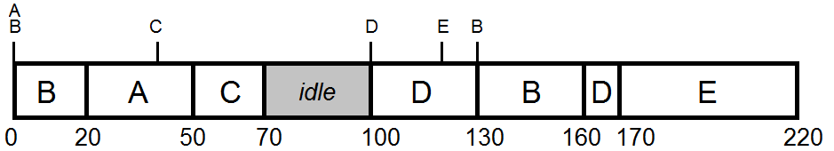Assumption: Scheduling using MQX policies (i.e. no pre-emption for same priority tasks becoming ready + pre-empted tasks stay at the front of the ready queue) -* (other solutions accepted as long as needed assumptions are made clear)